MA-packages in simulated retail conditions maintained sweet cherry fruit quality

H. Larsen¹ and J. Børve²

¹ Nofima – Norwegian Institute of Food, Fisheries and Aquaculture Research, Ås, Norway; ² NIBIO - Norwegian Institute of Bioeconomy Research, Lofthus, Norway.

Abstract
Modified atmosphere packaging (MAP) may inhibit undesirable quality changes of fruit and vegetables. The aim of this experiment was to evaluate the effect of MAP on selected quality parameters for sweet cherries (Prunus avium L.) stored at simulated distribution chain temperatures. ‘Lapins’ sweet cherries with maturity grade 4-5 and 6-7 were packaged in macroperforated polyethylene “carry bags” (control) and in trays wrapped in a laser perforated film giving passive modified atmosphere (MAP). After packaging, the cherries were stored at 4 °C for 5 days and thereafter for 3 days at 4 °C (Chill) or 20 °C (Retail) simulating storage at chill or room temperature in the grocery stores. Headspace gas atmosphere in the MA packages, fruit quality, weight loss and amount of fungal fruit decay and other decays were recorded after 1, 5 and 8 days of storage. The gas atmosphere in MA packages was approximately 18% O₂ and 4% CO₂ at 4 °C and between 6-9% O₂ and 12-14% CO₂ at 20 °C. The weight loss was negligible in the MA packages at both storage conditions, whereas the cherries in carry bags showed a weight loss from 1% to 4%. The stem colour was significantly browner in the carry bags compared to the MA packages after 8 days of retail storage. Fungal decay was below 0.5% for both maturity grades stored at chill conditions for 8 days. At retail conditions, 4% and 6% decay was detected for maturity grade 4-5 in MA-packages and carry bags, respectively. For maturity grade 6-7, the MA-packages had 9% decay and the carry bags 7%. The overall picture was that MA packaging for sweet cherries better maintained the fruit quality than the carry bags during the storage period of 8 days at two simulated retail conditions.

Keywords: gas atmosphere, storage temperature, stem colour, fungal decay, weight loss,
firmness, maturity grades

INTRODUCTION
The shelf life of fresh sweet cherries are limited due to factors such as fungal decay, stem browning, desiccation and tissue softening (Linke et al., 2010; Tian et al., 2004). Sweet cherries can have a shelf life of 14-21 days when stored at -1 to 0 °C with RH in the range 90 to 95% (Paull, 1999). This optimal low storage temperature is difficult to maintain during the whole distribution chain from the packinghouse to the consumer. According to (Paull, 1999), it is important to conduct storage experiments simulating conditions in commercial practise. In Norway, some grocery stores display cherries in chill cabinets, and others display them at ambient temperature. The cherries may be kept at room temperature for one to three days in the grocery stores. Consumers may also store the cherries at room temperature for many hours.
In Norway today, sweet cherries are packaged in open macroperforated polyethylene bags. Air storage in macroperforated bags or open containers induce desiccation of fruit and stems giving fruit weight loss and brown stems (Kappel et al., 2002; Koutsimanis et al., 2015; Padilla-Zakour et al., 2004). By packaging in modified atmosphere, benefits such as reduced weight loss and decay and maintaining red fruit colour, firmness and green stems can be achieved (Kappel et al., 2002; Koutsimanis et al., 2015; Padilla-Zakour et al., 2007). Today, MAP applications are already widely used by cherry producers around the world (Wani et al., 2014). The recommended MA atmosphere for cherries is 3-10 % O₂ and 10-20 % CO₂ (Koutsimanis et al., 2015; Wani et al., 2014). MAP technology is most efficient in combination with low storage temperature, and is not a substitute for cold temperature in extending shelf life (Kupferman and Sanderson, 2001). However, Alique et al. (2003) and Koutsimanis et al. (2015) found that packages with CO₂ concentrations within the range 10 to 20% significantly reduced fungal growth during two days at 23 °C after a previous storage period at 3 °C.
Microperforations is widely used to establish suitable gas atmospheres for fruit and vegetables in passive MA packages. Most of the gas transmission happens through the microperforations. If the products are stored at abusive temperatures, microperforated films may not provide the required increase in gas transmission rate in response to higher respiration rate, and detrimental low O₂ or high CO₂ levels might develop in the package (Koutsimanis et al., 2015; Larsen and Wold, 2016). Hence, the common practice is to design the package with perforations adapted to the highest temperature in the distribution chain (Beaudry, 2000). Koutsimanis et al. (2015) proposed a temperature adaptive passive MA package for cherries. The gas transmission rate in the packages was modified by removing a strip covering additional microperforations when the packages was moved from 3 °C to 23 °C. To our knowledge, this solution is not yet commercially available.
The aim of this work was to evaluate the effect of passive MA packaging compared to open carry bags and stored at two simulated realistic storage temperatures on sweet cherry quality parameters.

MATERIALS AND METHODS

Packaging and storage
‘Lapins’ cherries of a commercial delivery harvested in Lærdal (southwest in Norway) were cooled to 2 °C before packaging. At the packinghouse (Lærdal Grønt, Lærdal), the cherries were sorted in two maturity grades, less ripe with colour 4-5 and more ripe with colour 6-7 (Planton, 1995). The groups are in the following denoted Mat 4-5 and Mat 6-7. They were packaged in macroperforated polyethylene carry bags (standard packaging today with approximately 500g cherries in each bag, hereafter denoted CB ). After packaging the cherries were transported to Hardanger Fjordfrukt packinghouse (Utne, Norway) by a truck with cooling. At Hardanger Fjordfrukt half of the cherries were repacked in trays which were flow-wrapped in a laser perforated 25 µm polypropylene film. The amount of fruit in the trays differed between 400 and 500 g. The number of perforations were calculated on basis of previously measured respiration rates in order to achieve a CO₂ concentration above 10% at the highest storage temperature at 20 °C (hereafter denoted MAP). After repacking, half of the cherry packages was transported to Nibio Ullensvang (Lofthus) and the other half was transported to Nofima at Ås by a truck with cooling. At Nibio and Nofima the cherries were stored for 8 days at 4 °C (chill) or 5 days at 4 °C plus 3 days at 20 °C (retail). 15 samples were packaged for each treatment of cherries with maturity 4-5, whereas 8 to 12 samples was packaged for each treatment for maturity 6-7 due to limited delivery of this maturity grade.

Analyses
Oxygen and CO₂ in the headspace of the MA packages was measured by a Checkmate 9900 gas analyser (Dansensor, Ringsted, Denmark) at Nofima and by a Tiempo Test Silver gas analyser (Janny MT, Péronne, France) at Nibio. The gas samples were withdrawn through a septum placed on the packages using a needle connected to the gas analysers.
Weight loss was determined by weighing each of the packages with cherries at the day of packaging and after 8 days of storage. The number of packages weighed at chill and retail storage was 30 for MAP and 18 for CB, and 17 for MAP and 12 for CB for maturity grade 4-5 and 6-7, respectively. The weight loss was calculated as percentage loss of the initial total fruit weight.
At start of experiment, 3x10 fruit were taken out of one CB of each maturity grade and analysed for fruit quality. After five days at 4 °C and after 8 days at chill and retail storage another 3x10 fruit from the different experiment units were analysed. Fruit quality analysis included firmness (g/mm) on one side of each fruit by use of a Firmtech 2.0 texture analyzer (BioWorks Inc, Wamego, KS, USA) and fruit colour on every fruit judged by support of a scale from 1-7, where 1 is light red and 7 mahogany (Planton, 1995). Total soluble solids content (TTS, %) in mean of 10 fruit were measured on a mixture of 2 drops from each fruit in a refractometer (PR 101, Atago Co. Ltd., Tokyo, Japan). Stem colour on individual fruit was judged according to (Toivonen, 2014) where the visual stem browning was defined as; 1=0-25% of stems showing browning, 2=25-50% of stems showing browning, 3=50-75% of stems showing browning and 4=75-100% of stems showing browning. At end of storage number of fruit showing decay was counted. Fungal decay was diagnosed by typical visible signs and by use of microscopy. The fungal decay observed included Mucor rot caused by Mucor piriformis, grey mould caused by Botrytis cinerea, blue mould caused by Penicillium spp., brown rot caused by Monilina spp., Cladosporium rot caused by Cladosporium spp., Alternaria rot caused by Alternaria spp. and non-identified small spots of rotting. The latter was most probably mainly caused by grey mould although grey mould dominated on fruit from the same commercial delivery stored for a longer period.
Analysis of variance (ANOVA) was performed for all data (significance level p < 0.05) using general linear model in Minitab 17 Statistical Software (Minitab Inc., State College, PA, USA) and means were separated by Tukey’s multiple comparison test.

RESULTS AND DISCUSSION

Headspace gas concentrations in MA packages
The gas atmosphere in the headspace of the MA packages were measured after 8 days of storage. The O₂ concentrations was between 17.2% to 18.4% and the CO₂ concentration between 3.7% and 4.1% at chill storage. At retail storage, the O₂ concentration was between 6.4% to 9.3% and the CO₂ concentration varied from 12.1% to 14.3% (Figure 1).

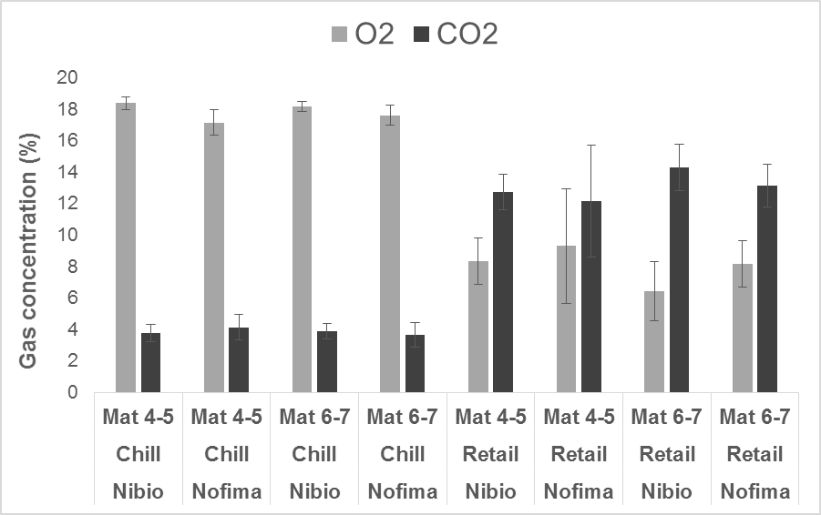

Figure 1. O₂ and CO₂ concentration measured at Nibio and Nofima in MA packages with
cherries with maturity 4-5 and 6-7 stored for 8 days at 4 °C (Chill) or 5 days at 4 °C and 3 days at 20 °C (Retail). Mean of 15 packages for maturity 4-5 and 8-12 packages for maturity 6-7.

The gas concentrations measured at Nibio and Nofima was almost equally. The small differences could be due to slightly different storage temperatures and different gas analysers. However, the overall picture demonstrates that packages with high O₂ concentration and low CO₂ concentration at 4 °C, gives O₂ and CO₂ concentrations within the recommended modified atmosphere range for cherries when stored at 20 °C. The recommended concentrations is 3-10 % O₂ and 10-20 % CO₂ (Koutsimanis et al., 2015; Wani et al., 2014).

Weight loss
It was no or a small negative weight loss (Figure 2) in the MA packages after 8 days of storage at both chill and retail temperature. The small negative weight loss in these packages could probably be explained by use of different weighing equipment at the start and end of the storage period. For the carry bags, the weight loss was approximately 2% and 4% at chill and retail storage, respectively. The weight loss was significantly lower for cherries in all the MA packages compared to the carry bags. Kappel et al. (2002 and Koutsimanis et al. (2015) also experienced significant differences in weight loss for micro perforated packages and macro perforated bags.

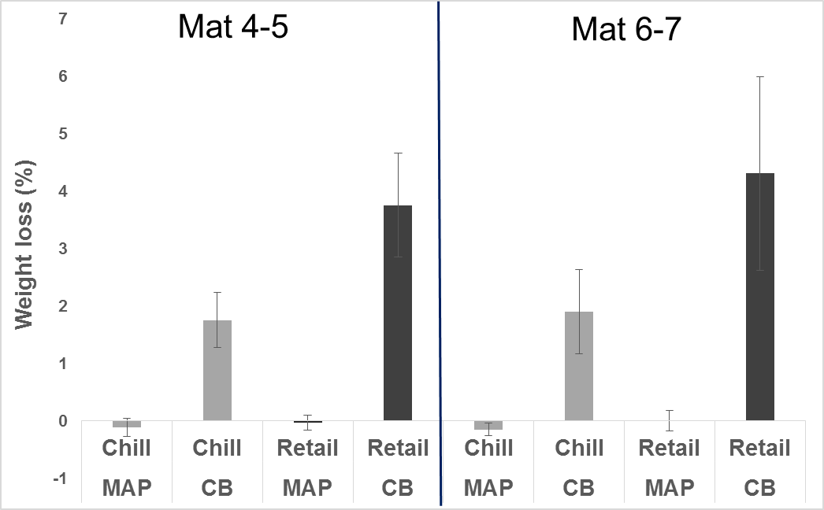

Figure 2. Weight loss for cherries maturity 4-5 and 6-7 packaged in modified atmosphere
(MAP) or carry bags (CB) and stored for 8 days at 4 °C (Chill) or 5 days at 4 °C and 3 days at 20 °C (Retail). Mean of 12-30 packages with 4-500g fruit.

Quality analyses
The two maturity grades was representing different fruit colour at start of experiment. The more ripe ones had also less firm fruit and higher total soluble solids content (Table 1). They were different in fruit colour and total soluble solids also after storage, but not in firmness. The brownest stems were on most ripe fruit in carry bags and the MAP kept the stems on the most mature fruit greener both at chill and retail conditions (Table 1). Green stem is an important quality factor (Linke, Herppich and Geyer, 2010). A positive effect of MAP on keeping green stems of ‘Lapins’ is reported before in a longer storage time (Kappel et al., 2002; Padilla-Zakour et al., 2004).

Table 1. Mean values and standard variation for firmness, total soluble solids, fruit colour and stem colour for cherries with two maturity grades at start of experiment and after 8 days of storage at chill or retail conditions packaged in MAP or carry bags. Different following letters in the same columns on data after storage indicate significant differences (p≤0.05) according to Turkey’s test. Mean of 3x10 fruit.

Maturity  grade | Storage | Packaging | Firmness  g/mm | TSS  (%) | Fruit colour | Stem  colour
Mat 4-5 | Start |  | 243.4 ± 8.8 | 15.1 ± 0.5 | 4.3 ± 0.2
Mat 6-7 | Start |  | 220.0 ± 6.7 | 17.8 ± 1.0 | 5.8 ± 0.2
Mat 4-5 | Chill | MAP | 257.0 ± 4.0ª | 14.9 ± 0.8^{b} | 4.7 ± 0.3^{bc} | 1.6 ± 0.5^{c}
Mat 4-5 | Chill | CB | 243.5 ± 10.4^{ab} | 14.4 ± 0.8^{b} | 4.4 ± 0.3^{c} | 1.3 ± 0.2^{c}
Mat 4-5 | Retail | MAP | 232.6 ± 11.3^{abc} | 13.8 ± 0.7^{b} | 4.7 ± 0.3^{bc} | 1.6 ± 0.2^{c}
Mat 4-5 | Retail | CB | 232.1 ± 10.3^{abc} | 14.8 ± 0.2^{b} | 5.1 ± 0.3^{b} | 2.2 ± 0.2^{bc}
Mat 6-7 | Chill | MAP | 226.8 ± 26.6^{abc} | 17.9 ± 0.9ª | 6.2 ± 0.2ª | 1.6 ± 0.5^{c}
Mat 6-7 | Chill | CB | 198.4 ± 8.1^{c} | 18.0 ± 1.0ª | 6.4 ± 0.2ª | 3.0 ± 0.3^{ab}
Mat 6-7 | Retail | MAP | 229.3 ± 16.8^{abc} | 18.8 ± 0.4ª | 6.2 ± 0.3ª | 2.0 ± 0.5^{c}
Mat 6-7 | Retail | CB | 212.5 ± 4.8^{bc} | 19.7 ± 0.7ª | 6.3 ± 0.2ª | 3.5 ± 0.1ª

Fungal decay
Fungal decay was below 0.5% for both maturity grades stored at chill conditions for 8 days (Figure 3) and it was no differences between packaging method or maturity grade. At retail conditions the decay was higher, between 4% and 9%. In mean of all observations it was more decay on fruit of maturity grade 6-7 than on of 4-5. Within each temperature and packaging combinations it was more decay of Mat 6-7 in MAP.

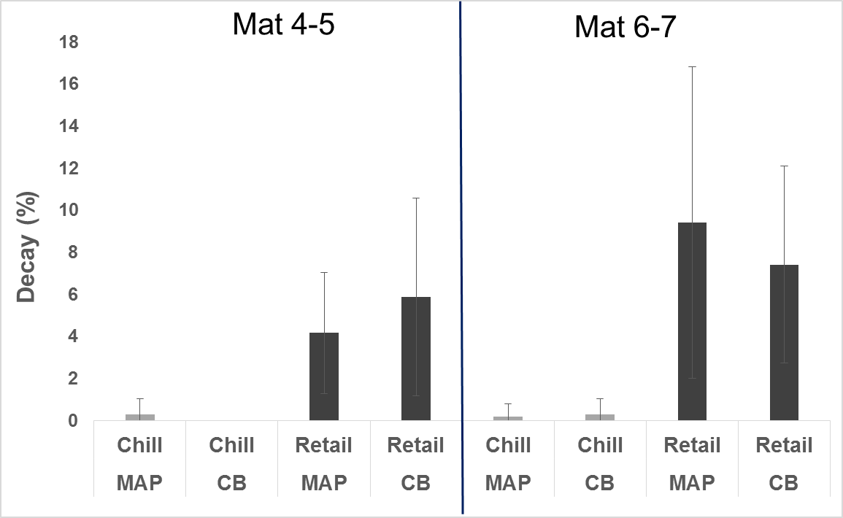

Figure 3. Fungal decay (%) in cherries with maturity 4-5 and 6-7 packaged in modified atmosphere (MAP) or carry bags (CB) and stored for 8 days at 4 °C (Chill) or 5 days at 4 °C and 3 days at 20 °C (Retail). Mean of 5-15 packages with 40-50 fruit.

There was no significant difference between MAP and carry bag in total fungal decay after eight days of storage at either chill or retail conditions.
At chill conditions, the CO₂ concentration at 4% was higher than in ambient air atmosphere, but lower than the recommended concentration of 10-20 % CO₂ (Koutsimanis et al., 2015; Wani et al., 2014). High CO₂ is reported having fungistatic effect on different fungal pathogens e.g. Monilinia fructicola (Tian et al., 2001). The main cause of fungal decay in the present experiment was non-identified small spots of rot, most probably caused by B. cinerea. In vitro experiments showed that B. cinerea was retarded by high CO₂ (Agar et al., 1990). However, requested level of CO₂ to obtain full effect was 25-30% and was higher than needed for M. fructicola. The second most common rot was Mucor rot. Tolerance of M. piriformis to CO₂ is not known, but the similar and closely related fungi Rhizopus stolonifer is retarded by high CO₂ (Koutsimanis et al., 2015). In their experiment with ‘Skeena’ cherries, the difference in decay appeared from two days at room temperature. However, the headspace CO₂ was higher in their experiment compared to ours, including the period of storage at 3 °C prior to the storage at 23 °C for two days. We might have seen an effect of MAP if the fruit had been kept for a longer time at 20 °C or had been stored for a longer time at 4 °C before moving to room temperature. However, different experiences with different cultivars and different fungal pathogens latent on the cherries underline the importance of performing experiments in the local conditions. In experiments with ‘Lapins’ a later harvest reduced storability in a longer storage period (Padilla-Zakour et al., 2007). In the present experiments it was more decay on the more mature fruit in MAP at retail conditions. It is reasonable to suggest that for a longer storage period the more mature fruit may have developed more decay.

CONCLUSIONS
It was no notable effect of MAP after 8 days at chill conditions, but at simulated retail conditions with 3 days at 20 °C following 5 days at 4 °C, a lower weight loss of maturity grades and less brown stems on Mat 6-7 were experienced showing a potential for maintaining a high fruit quality also in a short distribution time. The positive effect of keeping the fruit at low temperature was more important and was communicated to the industry.

ACKNOWLEDGEMENTS
Thanks to Lærdal Grønt for the supply of cherries, Hardanger Fjordfrukt for packaging the MA packages on their flowpack machine, Lene Øverby and Karen Wahlstrøm Sanden at Nofima for assistance in gas sampling and weighing, technicians at Nibio Ullensvang for performance of gas analyses and quality analyses, and The Research Council of Norway for financial support.

Literature cited

Agar, T., Garcia, J., Miedtke, U. and Streif, J. 1990. Effect of high CO₂ and low O₂ concentrations on the growth of Botrytis cinerea at different temperatures/wirkung von hohen CO₂ und niedrigen O₂ konzentrationen auf das wachstum von Botrytis cinerea bei unterschiedlichen temperaturen. Gartenbauwissenschaft, 219-222.

Alique, R., Martínez, M.A. and Alonso, J. 2003. Influence of the modified atmosphere packaging on shelf life and quality of Navalinda sweet cherry. Eur. Food Res. Technol. 217, 416-420.

Beaudry, R.M. 2000. Responses of horticultural commodities to low oxygen: limits to the expanded use of modified atmosphere packaging. HortTechnology 10, 491-500.

Kappel, F., Toivonen, P., McKenzie, D.-L. and Stan, S. 2002. Storage characteristics of new sweet cherry cultivars. HortScience 37, 139-143.

Koutsimanis, G., Harte, J. and Almenar, E. 2015. Development and evaluation of a new packaging system for fresh produce: a case study on fresh cherries under global supply chain conditions. Food Bioprocess Tech 8, 655-669.

Kupferman, E. and Sanderson, P. 2001. Temperature management and modified atmosphere packing to preserve sweet cherry fruit quality. Proc. IV International Cherry Symposium 667, p. 523-528.

Larsen, H. and Wold, A.-B. 2016. Effect of modified atmosphere packaging on sensory quality, chemical parameters and shelf life of carrot roots (Daucus carota L.) stored at chilled and abusive temperatures. Postharvest Biol Technol 114, 76-85.

Linke, M., Herppich, W.B. and Geyer, M. 2010. Green peduncles may indicate postharvest freshness of sweet cherries. Postharvest Biol Technol 58, 135-141.

Padilla-Zakour, O., Ryona, I., Cooley, H., Robinson, T., Osborne, J. and Freer, J. 2007. Shelf-life extension of sweet cherries by field management, post-harvest treatments and modified atmosphere packaging. New York fruit quarterly.

Padilla-Zakour, O., Tandon, K. and Wargo, J. 2004. Quality of modified atmosphere packaged ‘Hedelfingen' and ‘Lapins' sweet cherries. HortTechnology 14, 331-337.

Paull, R. 1999. Effect of temperature and relative humidity on fresh commodity quality. Postharvest Biol Technol 15, 263-277.

Planton, G. 1995. Cherry: a color code to improve crop quality. Infos CTIFL (France).

Tian, S.-P., Jiang, A.-L., Xu, Y. and Wang, Y.-S. 2004. Responses of physiology and quality of sweet cherry fruit to different atmospheres in storage. Food Chem 87, 43-49.

Tian, S., Fan, Q., Xu, Y., Wang, Y. and Jiang, A. 2001. Evaluation of the use of high CO₂ concentrations and cold storage to control of Monilinia fructicola on sweet cherries. Postharvest Biol Technol 22, 53-60.

Toivonen, P.M. 2014. Integrated analysis for improving export of sweet cherries and how a small industry can compete by focusing on premium quality. Proc. V International Conference Postharvest Unlimited 1079. p. 71-82.

Wani, A.A., Singh, P., Gul, K., Wani, M.H. and Langowski, H. 2014. Sweet cherry (Prunus avium): Critical factors affecting the composition and shelf life. Food Packaging and Shelf Life 1, 86-99.

