Effect of broccoli phytochemical extract on release of fatty acids from salmon muscle and salmon oil during in vitro digestion
K. E. Aarak^{1,2}, B. Kirkhus², S. Johansen², G. E. Vegarud¹ and G. I. A. Borge²
¹Department of Chemistry-, Biotechnology and Food Science, UMB, Ås, Norway.
²Nofima, Norwegian Institute of Food, Fisheries and Aquaculture Research, Ås, Norway.

Correspondence to: Grethe Iren A. Borge, Nofima AS, P.O.Box 210, NO-1431 Ås, Norway. Telephone: +47 64970238, Fax: +47 64970333, E-mail: grethe.iren.borge@nofima.no
Financial support: The project was supported by the Norwegian Research Council and the Foundation for Research Levy on Agricultural products in Norway
Running title: In vitro digestion of salmon and broccoli
Hypothesis: Components in broccoli may affect lipid digestion.

Word count: Abstract: 260 Total: 3938 (ex. References, figures an tables)
Figures: 3
Tables: 2
Abstract
The aim of the present work was to study the effect of a broccoli phytochemical extract (Br-ex) on the release of fatty acids (FA) from salmon muscle (SM) and salmon oil (SO) during in vitro digestion. The hypothesis of the study was that Br-ex contains polyphenols which might act as pancreatic lipase inhibitors. The effect on the release of specific FA, in particular the long-chain n-3 polyunsaturated fatty acids (PUFAs), EPA (C20:5 n-3) and DHA (C22:6 n-3), was recorded, and the impact of the SM matrix was studied by comparing the release of FA from SM and SO. In vitro digestion was performed and lipolytic activity, measured as the release of fatty acids (FFA) by solid phase extraction and GC-FID, was recorded at 20, 40, 80 and 140 minutes in intestinal phase. The results showed, unexpectedly, that Br-ex stimulated the release of FA during digestion of SO and SM, showing the highest increases in FFA, 67 % and 64 %, respectively, at 20 min. No difference in the release of FA from SO compared to SM was observed, suggesting that the SM matrix had minor influence on the lipolytic activity. The results also demonstrated that the increase in lipolytic activity caused by Br-ex was not affected by the SM matrix. However, addition of Br-ex resulted in a lower percentage of EPA and DHA in the FFA fraction, suggesting that the lipase sn-position preference was altered. Whether this affects the bioaccessibility of EPA and DHA needs further investigation.

Key words: broccoli, DHA, EPA, in vitro digestion, lipolysis, polyphenols, salmon
Introduction
The association between nutrition and health is complex. During digestion food constituents interact and their bioaccessibility and bioactivity may be influenced by the food matrix ¹. It is therefore important to gain more knowledge not only about the overall quality of the diet, but also interactions between meal components that best promote health. Phytochemicals in vegetables have been associated with anti-obesity properties, partly by inhibiting the pancreatic lipase ^{2, 3}. Pancreatic lipase is the main enzyme responsible for lipid hydrolysis in the human gastro intestinal tract ⁴, and inhibition of this enzyme might decrease the overall lipid absorption ^{5, 6}. Furthermore, undigested lipids that reach ileum have been shown to stimulate the release of gut hormone peptides increasing sensation of satiety ⁷⁻⁹. Several studies have emphasized the need for exploring natural inhibitors of digestive enzymes ¹⁰⁻¹³, and lipase inhibitors from various plants have been screened for their lipase inhibiting activity ^{14, 15}. Orlistat, a drug for treating obesity, and a potent pancreatic lipase inhibitor, has been shown to reduce body weight in obese subjects with metabolic risk factors ¹⁶. However, many anti-obesity drugs have been withdrawn from market due to adverse side effects or unfavourable risk to benefit ratios ¹⁷. Moreover, the effect of drugs on long-term obesity prevention has been shown to be limited ¹⁸. Strategies to combat obesity by developing foods or meals that increase satiety and improve weight control are therefore highly relevant.
Polyphenols in plant-based foods are natural phytochemical compounds which have previously been suggested to inhibit pancreatic lipase ^{15, 19}, but the mechanism remains unknown. Broccoli is a rich source of polyphenols ^{20, 21}, containing mainly flavonol glycosides and hydroxycinnamic acids ²². Hence, caffeic and ferulic acid, the main phenolic acids in broccoli ²², have a high potential for lipase inhibition ²³. Most of the studies which have been conducted with regard to polyphenols and lipase activity have employed simple systems with only one lipolytic enzyme and a simple substrate, typically containing only one type of FA. On the basis of this there seem to be a need for conducting these types of studies using more comprehensive in vitro models, e.g. including digestive enzymes for all macromolecules in order to digest complex solid foods.
In a recent study, the release of FA from salmon muscle (SM) during duodenal in vitro digestion was affected by the presence of heat-treated broccoli, showing an initial delay of lipolysis followed by increased release of FA after 80 min digestion¹. Consequently, the aim of the present study was to investigate whether the observed effect could be attributed to the polyphenols present in the broccoli. For this study a methanol/water broccoli extract (Br-ex), rich in polyphenols, was added to salmon oil (SO) and cooked SM and the release of FA during duodenal digestion was recorded. Moreover, salmon is known to be a good dietary source of the long-chain n-3 PUFAs, EPA and DHA, known to have several positive health implications. Consequently, it was of particular interest to study the release of these FA from SO and SM during digestion and whether the release was influenced by addition of Br-ex.

Experimental methods
Raw materials
Salmon muscle (SM) from Atlantic salmon (Salmo salar) containing 16 % fat was obtained from Bremnes Seashore AS, Bremnes, Norway, grinded, vacuum-packed and stored at -20 °C. Samples (100 g) of grinded SM were defrosted over night at 4 °C, transferred into plastic bags (2-3 mm layer) and vacuum-packed. The vacuum-packed samples were heated (70 °C, 2 min) in a water bath and cooled on ice before freezing at -20 °C. Salmon oil (SO) from Atlantic salmon (Salmo salar) was obtained from Denomega (Denomega Nutritional Oils, Sarpsborg, Norway). The fatty acid compositions of SM and SO are given in Table 1. Broccoli (Br), (Brassica oleracea, L. var. italica, cv. Ironman), was obtained from a commercial grower on Jeløy, Moss, Norway. Broccoli florets (10-30 g) with 2 cm stalks were vacuum-packed in plastic bags, heated in water bath (97 °C, 5 min) and cooled for 3 min in water with ice before rapidly being frozen on aluminium plates at -40 °C. After freezing, all samples were stored at -80 °C until used in the in vitro digestion experiments.

Preparation of broccoli extract (Br-ex)
Frozen, heat-treated broccoli floret samples were pulverized inside the plastic bags using a hammer. A broccoli extract (Br-ex) was prepared using methanol (MeOH) as extraction solvent, 100 % MeOH in the first extraction step and 80 % MeOH/water (v/v) in the second, as described by Olsen et al. (2009) ²⁴. Before in vitro digestion, the extract was evaporated under N₂ and resolved in 20 % v/v MeOH in water (3 g broccoli/ml).

In vitro digestion
The in vitro digestion model used consisted of a gastric and a duodenal step, based on a model described by Aura et al. ²⁵. The duodenal protocol was recently optimized for lipid digestion using commercial porcine enzymes ²⁶. Pepsin (porcine, Sigma P7000, 683 U/mg solid), pancreatin (porcine, Sigma P1750), bile acid mixture (ovine and bovine, Sigma B8381) and mucin (porcine, Sigma M2378) were obtained from Sigma-Aldrich Co. (St. Louis, MO, USA).
In order to measure the effect of the SM matrix, SM was compared with SO and the SM matrix replaced with water. SM (0.750 g) or SO (0.125 g + 0.625 g H₂O) were placed in tubes, and 250 µl Br-ex (3.0 g/ml, 20% MeOH v/v) or 250 µl H₂O were added. The gastric phase was simulated by adding 2.0 ml 0.9 % NaCl, 1.5 ml H₂O and 1 ml pepsin solution (0.174 mg pepsin per ml final volume). HCl (1 M) was used for adjustment of pH to 2.5. The tubes were incubated in a rotary incubator (Bench top Incubator Shakers, New Brunswick Scientific, USA) at 37 °C, 215 rpm, for 60 minutes before addition of 3 ml simulated duodenal fluid consisting of 2 ml 0.15 M NaHCO₃, 1 ml H₂O, mucin (1.2 mg/ml final volume), pancreatin (1.2 mg/ml final volume) and bile salts (11.8 mM in final volume). Tubes were withdrawn at 20, 40, 80 and 140 minutes, placed on ice, and CHCl₃: MeOH (2:1 v/v) was immediately added in order to stop the hydrolysis. The experiments were repeated three times (n=3), and analysed in duplicate at each time point.
For comparison, the lipase inhibitor Orlistat was added to the in vitro digestion of SO and the release of FA quantified after 80 minutes in duodenal phase. A dose similar to 1/200 capsule was used in order to adjust for the amount of lipids present in the model. Furthermore, the effect of MeOH (0.8 % in duodenum phase) on lipolysis was also investigated as a control. In order to compare the polyphenol profile during in vitro digestion of broccoli and Br-ex, respectively, grinded heat-treated broccoli (750 mg) and Br-ex were subjected to the in vitro digestion model. Digested samples withdrawn at 20, 40, 80 and 140 minutes in duodenal phase were centrifuged (39 000 x g, 15 min, 4°C), and polyphenols in the supernatants were analyzed by HPLC. The lipid content of the Br-ex were not analysed.

Lipid extraction and analysis of fatty acids
An internal standard, C23:0 (methyl tricosanoate, Larodan Fine Chemicals AB, Sweden), was used for the quantification of FA in the FFA fraction. Lipids were extracted from the digesta according to Bligh and Dyer (1959) ²⁷ and separated into lipid classes, i.e. free fatty acids (FFA), neutral lipids (mono-, di- and triacylglycerols) and polar lipids using an automated solid phase extraction (SPE) system (Gerstel MPS Autosampler, Gerstel GmbH, Switzerland) using a modified and in-house validated method based on Ruiz et al. ²⁸. FFA were eluted with diethyl ether:acetic acid (v/v 99:1), and the solvent was removed by evaporation under N₂ before the fatty acids were derivatized using 3M methanolic HCl. The methyl esters were analysed using a gas chromatography (GC) with flame ionization detection (FID). Briefly, lipids were derivatized and analysed as methyl esters using an Agilent 6890 capillary gas chromatograph (GC) equipped with a BPX-70 column, 60 m x 0.25 mm i.d., 0.25 μm film (SGE Analytical Science Pty Ltd, Ringwood, Australia). The temperature program started at 70 °C for 1 min, increased by 30 °C/min to 170 °C, 1.5 °C/min to 200 °C and 3 °C/min to 220 °C with a final hold time of 5 minutes. Peaks were integrated with Agilent GC ChemStation software (rev. A.05.02) (Agilent Technologies, Little Falls, DE), and identified by use of external standards. Coefficients of variation were < 5 %. Total lipid hydrolysis was measured as mg FFA per g lipids in the raw materials SO and SM. The release of a specific FA is presented as mg free fatty acid (FFA) per g present in the raw materials SO and SM (mg/g FA), or presented as % of total FA in the FFA fraction.

HPLC analysis
Phenolic compounds in Br-ex and digested broccoli were analyzed using an Agilent 1100 series HPLC system (Agilent Technologies) equipped with an auto sampler cooled to 4 °C and a photodiode array detector (180-600 nm) as earlier described ²⁴. Chromatographic separation was performed on a Betasil RP-C₁₈ column (250 x 2.1 mm i.d., 5 µm particle size) equipped with a C₁₈ guard column (4.0 x 2.1 mm i.d., 5 µm particle size), both from Thermo Hypersil-Keystone (Bellefonte, PA). The column temperature was set to 30 °C, and the injection volume was 5 µl. Solvent A consisted of acetic acid/water (2:98, v/v), and solvent B consisted of acetonitrile/acetic acid/water (50:2:48, v/v/v). The elution gradient profile used was 10-45% B in 60 min, 45-100% B in 10 min, followed by 7 min 100 % B, with at flow rate of 0.25 ml/min. Naturally occurring flavonols and phenolic acids derivatives were detected at 330 nm, and the peak areas were used to compare the contents of polyphenols in the digested samples.

Statistical analyses
All values are presented as mean values with their standard deviations (SD). Student’s t test (two-sample, assuming equal variance) was used to estimate significant differences (GraphPad Prism x6). The difference were considered significant when P<0.05, and P-values are given in the respective results and figures. ANOVA (one-way) (Minitab 16, Minitab Ltd, UK) was performed when studying the release of EPA and DHA, using digestion time (duodenal phase) and Br-ex as variables, and % EPA and % DHA in the FFA fraction as response variables.
Results
The fatty acid (FA) compositions of salmon oil (SO) and cooked salmon muscle (SM) are given in Table 1. The composition differed, i.e. the oil contained higher levels of EPA and DHA and lower levels of C18:1 and C18:2 than the fish muscle (Table 1). However, no significant differences were observed between SM and SO regarding the overall release of FA during in vitro duodenal digestion (Fig. 1A). Addition of broccoli extract (Br-ex) to the in vitro digestion of SO and SM resulted in a significant increase in FFA content at 20 and 40 minutes (Fig. 1A and B). The release of FA from SO increased with 67 % (from 144 ± 21 to 241 ± 22 mg FFA/g lipid) at 20 minutes, and 24 % (from 217 ± 27 to 269 ± 6 mg FFA/g lipid) at 40 minutes (Fig. 1B), while the release of FA from SM increased with 64 % (from 131 ± 36 to 216 ± 26 mg FFA/g lipid) and 59 % (from 180 ± 56 to 287 ± 52 mg FFA/g lipid), respectively (Fig. 1C). The positive control, Orlistat, reduced the lipolytic activity by 87 ± 6 % after 80 min digestion of SO (results not shown). Another control performed was the effect of the extraction solvent methanol (MeOH) on the lipolytic activity. Results showed that the MeOH concentration in duodenal phase (0.8 % v/v) had no effect on the release of FA from SO or SM (results not shown). Furthermore, the polyphenol profiles (specific polyphenols) and concentrations in digested samples with Br-ex did not change with time during duodenal digestion (results not shown). When comparing polyphenol profiles of heat-treated broccoli and Br-ex during in vitro digestion, no significant differences were observed at any time point.

As expected, the content of FFA (Fig. 1), as well as the release of specific fatty acids (Table 2), increased during duodenal digestion of SO and SM. However, the release of EPA and DHA reached only 7-17 % at 140 min, while the release of other fatty acids reached 20-54 % (Table 2). Co-digesting Br-ex with SO and SM increased the release of all fatty acids, except EPA and DHA (Table 2), which resulted in a lower percentage of EPA and DHA in the FFA fraction. ANOVA showed that addition of Br-ex to SM resulted in a significantly lower percentage of EPA (P<0.001) and DHA (P=0.001) in the FFA fraction (Fig. 2). A similar trend was observed for SO, but this effect was not found to be significant. Furthermore, in contrast to SM, the percentages of EPA and DHA in the FFA fractions from SO increased significantly (P=0.002) with time in the duodenal phase.

Discussion
This study shows that a methanolic extract from broccoli (Br-ex), increased the release of FA from salmon oil (SO) and salmon muscle (SM) during in vitro duodenal digestion. No difference between SO and SM regarding overall lipolytic activity and effect of Br-ex was observed. The increase in release of total FA was only found to be significant during the first 40 minutes of the digestion. The present study was based on a previous experiment where broccoli and SM were digested together, as in a meal, using a semi-dynamic in vitro digestion model ¹. The former experiment showed that broccoli inhibited the release of FA from SM during the first 40 minutes of in vitro digestion, followed by a stimulation of the lipolytic activity. The following increase in lipolysis was suggested to be due to methodological issues related to performing in vitro lipolysis in a closed system¹, whereas the initial inhibitory effect of broccoli was suggested to be due to lipase inhibition by polyphenols ^{29, 30}.
Unexpectedly, the present study showed that Br-ex caused an initial increase in the release of FA from SM, as well as SO, during in vitro digestion. Several parameters and mechanisms might explain the contradictory results observed in the two studies. Firstly, two different in vitro models were employed, a static and a semi-dynamic model, respectively. Hence, the overall conditions of the studies were different. For instance, concentrations of electrolytes and enzyme preparations were different, using porcine individual enzymes in the semi-dynamic model employed in the first study ¹, while using porcine pancreatin in the present study. A study performed by Carrière et al. (2000) showed that lipolysis might be affected by different enzyme preparations ³¹. This could potentially also affect the hydrolysis of polyphenols and influence the effect on pancreatic lipase activity. Polyphenols are present in plant foods mainly in the native form of esters, glycosides and polymers, which by the action of different intestinal and microbial enzymes are hydrolyzed, increasing their absorbability and their chemical reactivity ^{32, 33}. Secondly, the broccoli matrix might affect the release of phytochemicals, and consequently affect the lipolytic activity. This assumption is supported by a study performed by Prior et al. (2008) ³⁴, showing that extracted/purified polyphenols exerted lipase inhibition, while whole berries had no effect. In order to investigate whether the release of polyphenols was affected by the broccoli matrix, the polyphenol profiles in the digesta with cooked minced broccoli and Br-ex were compared. Results showed similar polyphenol profiles during in vitro digestion, suggesting that the observed differences in FA release in this and the previous study ¹ cannot be explained by differences in polyphenol profile. Although the two studies were designed to ensure equal doses of polyphenols, variations in duodenal concentration and a potential dose-response effect cannot be excluded. Thirdly, the previously observed effect of broccoli, inhibiting the lipolysis ¹, might be due to other components within the broccoli which were not transferred to the Br-ex. These contradictory findings need to be further examined, as well as other potential compound(s) in broccoli that may influence lipolysis.
Previous studies have demonstrated effects of polyphenols on the bioavailability of macro-molecules in foods. Furthermore, polyphenols have been shown to partly exert their action through binding to proteins, as reviewed by Bandyopadhyay et al. 2012 ³⁵. It was therefore of interest to study whether the SM matrix influenced the effect of Br-ex, comparing the protein rich SM and the protein free SO. The present results suggest that the higher lipolytic activity observed caused by Br-ex was not affected by the SM matrix. Moreover, there are several other components in Br-ex which might affect the lipolytic activity, for instance minerals or compounds with emulsifying properties. Broccoli has a high mineral content ³⁶, in particular calcium (Ca⁺⁺) which has previously been shown to increase lipase activity ^{37, 38}. Also Ca⁺⁺ binding to FA, making FA(Ca)-soaps, might affect the rate of lipolysis ³⁹. In plant tissues Ca⁺⁺ is bound to macromolecules in the cell wall, as well as being present in the vacuole ⁴⁰, suggesting that Ca⁺⁺ will be released during in vitro digestion when the macromolecule structures are broken down. Whether calcium present in Br-ex caused the enhancing effect on lipolysis needs to be further determined.
The increase in lipolysis could also be due to emulsifying components in the Br-ex increasing the surface area of lipid droplets in the duodenal phase, and thereby enhance the lipolytic activity ⁴¹. Our previous study showed that broccoli easily dispersed lipid droplets during digestion of SM ¹. The emulsification properties may be partly due to the action of proteins and peptides that are well known to absorb to the oil-water interface. This hypothesis is only partly supported by data from the present study, showing a somewhat higher, although not significant, increase in the release of FA from SM compared to SO.
Food matrix has previously been shown to affect lipolysis ⁴²⁻⁴⁴. However, this was not shown in the present study where lipolysis of SO versus SM was compared, and the overall release of FA from SO was similar to SM. Using extracted lipids from the salmon, instead of a commercial salmon oil, could have given more exact information about the effect of the food matrix. Phospholipids can also contribute to the production of absorbable FA, however, the amount of phospholipids in SM is low compared to the amount of triglycerides. In this study we observed a similar release of FA from SO and SM despite differences in the food matrix and FA composition.
Specific FA were released to various extents from both SO and SM, with DHA showing the lowest release (7 %) and C20:1 showing the highest release (50 %) after 140 min in duodenal phase. This is mainly due to different positions of the specific FA in the triacylglycerol (TAG) molecule. The position of FA on TAGs in marine oils has previously been described ⁴⁵, showing that C16:1, C18:1(n-9), C20:1(n-9) and C18:3 are mainly distributed in sn-1 and sn-3 (>70 %), whereas C14:0 (approx. 50 %), C16:0 (approx. 45 %), EPA (C20:5) (approx. 47 %) and DHA (C22:6) (approx.76 %) are mainly found in sn-2 position. However, C14:0, C16:0 and EPA are, together with C18:2, more randomly distributed in all the sn-positions than the other FA on the TAG. Several parameters have previously been shown to influence the release of specific FA, e.g. the sn-position of the FA and the pancreatic lipases position preference ⁴⁶, as well as chain length and the position of the first double bond ⁴⁷. This is in accordance with the present results showing that the long-chained PUFAs EPA and DHA, having their first double bond at carbon number three (n-3), are released to a much smaller extent compared to other FA primarily found in sn-2 position. Addition of Br-ex affected the release of specific FA differently, probably due to changes in the lipase position preference. In contrast to other FA, the release of n-3 PUFAs EPA and DHA was not increased by Br-ex, which resulted in a lower percentage of EPA and DHA in the FFA fraction. Since the release of EPA and DHA from the sn-2 position was not measured in this study it is not known to what extent Br-ex affected their bioaccessibility.

Concluding remarks
In the present study the effect of a polyphenol-rich broccoli extract (Br-ex) on the release of fatty acids (FA), both the total and the specific FA, from salmon oil (SO) and salmon muscle (SM), was examined using an in vitro digestion model. Unexpectedly, digestion of SO or SM together with Br-ex resulted in an initial increase in the total amount of released FA. As there were no differences in the effect of Br-ex on lipid digestion of SO and SM, it is suggested that the increased lipolytic activity caused by Br-ex was not influenced by the SM matrix. The results further indicate that the SM matrix had minor impact on overall release of FA, as well as release of specific FA. However, the release of specific FA from sn-1 and sn-3 position on the TAG molecule was affected by Br-ex, resulting in a lower percentage of EPA and DHA in the FFA fraction. In conclusion, the results indicate that broccoli phytochemicals, or other components present in the Br-ex, influence the release of FA, suggesting that the composition of the ingredients in a meal is important for lipid digestion.
Acknowledgements
This work was supported by the Norwegian Research Council (RCN project 202379/I10). Financial support from the Foundation for Research Levy on Agricultural products in Norway is also gratefully acknowledged. We thank Silje Johansen and Elin-Merete Nicolaisen for analytical assistance, and Dr. Gunnar B. Bengtsson for providing the broccoli. The authors are participants in the COST Action FA1005, Improving health properties of food by sharing our knowledge on the digestive process (INFOGEST).
Conflict of interest
The authors report no conflict of interest, and are individually responsible for the content and writing up this manuscript.
References
1. K. E. Aarak, N. M. Rigby, B. Kirkhus, L. J. Salt, S. Sahlstrom, G. B. Bengtsson, G. E. Vegarud and A. R. Mackie, Food & Function, 2013, 4, 1819-1826.
2. E. H. Jeffery, A. F. Brown, A. C. Kurilich, A. S. Keck, N. Matusheski, B. P. Klein and J. A. Juvik, Journal of Food Composition and Analysis, 2003, 16, 7.
3. D. J. Williams, D. Edwards, I. JHamernig, L. Jian, A. P. James, S. K. Johnson and L. C. Tapsell, Food Research International, 2013, 52, 10.
4. F. H. Mattson and R. A. Volpenhein, The Journal of Biological Chemistry, 1964, 239, 2772-2777.
5. P. W. Maljaars, H. P. Peters, D. J. Mela and A. A. Masclee, Physiology & behavior, 2008, 95, 271-281.
6. L. Marciani, M. Wickham, G. Singh, D. Bush, B. Pick, E. Cox, A. Fillery-Travis, R. Faulks, C. Marsden, P. A. Gowland and R. C. Spiller, American Journal of Physiology. Gastrointestinal and Liver Physiology, 2007, 292, G1607-1613.
7. R. L. Batterham, M. A. Cowley, C. J. Small, H. Herzog, M. A. Cohen, C. L. Dakin, A. M. Wren, A. E. Brynes, M. J. Low, M. A. Ghatei, R. D. Cone and S. R. Bloom, Nature, 2002, 418, 650-654.
8. A. D. Strader and S. C. Woods, Gastroenterology, 2005, 128, 175-191.
9. P. W. Maljaars, T. Symersky, B. C. Kee, E. Haddeman, H. P. Peters and A. A. Masclee, International Journal og Obesity (Lond), 2008, 32, 1633-1639.
10. Y. Shi and P. Burn, Nature reviews. Drug discovery, 2004, 3, 695-710.
11. K. E. Foster-Schubert and D. E. Cummings, Endocrine reviews, 2006, 27, 779-793.
12. K. K. Bhutani, R. B. Birari and K. Kapat, Natural Product Communication, 2007, 2, 17.
13. A. L. de la Garza, F. I. Milagro, N. Boque, J. Campion and J. A. Martinez, Planta Medica, 2011, 77, 773-785.
14. R. B. Birari and K. K. Bhutani, Drug Discovery Today, 2007, 12, 879-889.
15. P. Slanc, B. Doljak, S. Kreft, M. Lunder, D. Janes and B. Strukelj, Phytotherapy Research : PTR, 2009, 23, 874-877.
16. S. Tonstad, D. Pometta, D. E. Erkelsen, L. Ose, T. Moccetti, J. A. Schouten and P. van der Wal, European Journal of Clinical Pharmacology, 1994, 46, 5.
17. J. G. Kang and C. Y. Park, Diabetes & Metabolism Journal, 2012, 36, 13-25.
18. J. Kaukua, T. Pekkarinen, T. Sane and P. Mustajoki, International Journal Obesity Related Metabolic Disorders, 2003, 27, 1072-1080.
19. D. A. Moreno, N. Ilic, A. Poulev, D. L. Brasaemle, S. K. Fried and I. Raskin, Nutrition, 2003, 19, 876-879.
20. G. B. Bengtsson, R. Schönera, E. Lombardoa, J. Scönera, G. I. A. Borge and W. Bilgerb, Postharvest Biology and Technology 2006, 39, 7.
21. F. Vallejo, D. Tomas-Barberan and C. Garcia-Viguera, Journal of Agricultural and Food Chemistry, 2003, 51, 5.
22. F. Vallejo, F. A. Tomas-Barberan and F. Ferreres, Journal of Chromatography. A, 2004, 1054, 181-193.
23. M. Karamac and R. Amarowicz, Zeitschrift fur Naturforschung. C, Journal of Biosciences, 1996, 51, 903-905.
24. H. Olsen, K. Aaby and G. I. A. Borge, Journal of Agriculture and Food Chemistry, 2009, 57, 2816-2825.
25. A. M. Aura, H. Harkonen, M. Fabrititus and K. Poutanen, Journal of Ceral Science, 1999, 29, 13.
26. K. E. Aarak, B. Kirkhus, H. Holm, G. Vogt, M. Jacobsen and G. E. Vegarud, British Journal of Nutrition, 2013, 10, 1402-1410.
27. E. G. Bligh and W. J. Dyer, Canadian Journal of Biochemistry and Physiology, 1959, 37, 911-917.
28. J. Ruiz, T. Antequera, A. I. Andres, M. Petron and E. Muriel, Analytica Chimica Acta, 2004, 520, 201-205.
29. M. Nakai, Y. Fukui, S. Asami, Y. Toyoda-Ono, T. Iwashita, H. Shibata, T. Mitsunaga, F. Hashimoto and Y. Kiso, Journal of Agriculture and Food Chemistry, 2005, 53, 4593-4598.
30. G. J. McDougall and D. Stewart, Biofactors, 2005, 23, 189-195.
31. F. Carriere, C. Renou, V. Lopez, J. De Caro, F. Ferrato, H. Lengsfeld, A. De Caro, R. Laugier and R. Verger, Gastroenterology, 2000, 119, 949-960.
32. C. Manach, A. Scalbert, C. Morand, C. Remesy and L. Jimenez, American Journal of Clinical Nutrition, 2004, 79, 727-747.
33. J. Bouayes, H. Deusser, L. Hoffmann and T. Bohn, Food Chemistry, 2012, 131, 6.
34. R. L. Prior, X. Wu, L. Gu, T. J. Hager, A. Hager and L. R. Howard, Journal of Agriculture and Food Chemistry, 2008, 56, 647-653.
35. P. Bandyopadhyay, A. K. Ghosh and C. Ghosh, Food & Function, 2012, 3, 592-605.
36. R. Puupponen‐Pimiä, S. T. Häkkinen, M. Aarni, T. Suortti, A. M. Lampi, M. Eurola, V. Piironen, A. M. Nuutila and K. M. Oksman‐Caldentey, Journal of the Science of Food and Agriculture, 2003, 83, 1389-1402.
37. M. Armand, B. Pasquier, M. Andre, P. Borel, M. Senft, J. Peyrot, J. Salducci, H. Portugal, V. Jaussan and D. Lairon, American Journal of Clinical Nutrition, 1999, 70, 1096-1106.
38. M. Hu, E. A. Decker and D. J. McClements, Food Hydrocolloids, 2010, 24, 6.
39. N. H. Zangenberg, A. Mullertz, H. G. Kristensen and L. Hovgaard, European Journal of Pharmaceutical Sciences: official journal of the European Federation for Pharmaceutical Sciences, 2001, 14, 115-122.
40. D. S. Wilson and A. J. Clifford, in Nutrition: Eating for Good Health, ed. D. T. Smith, The US Department og Agriculture, Washington DC, USA, 1990, pp. 72-77.
41. H. Singh, A. Ye and D. Horne, Progress in Lipid Research, 2009, 48, 92-100.
42. D. J. McClements, E. A. Decker and Y. Park, Critical Rewievs in Food Science and Nutrition, 2008, 49, 19.
43. D. J. McClements, E. A. Decker, Y. Park and J. Weiss, Food Biophysics, 2008, 3, 219-228.
44. D. J. McClements and Y. Li, Advances in Colloid and Interface Science, 2010, 159, 213-228.
45. H. Brockerhoff, R. J. Hoyle, P. C. Hwang and C. Litchfield, Lipids, 1968, 3, 24-29.
46. E. Rogalska, S. Ransac and R. Verger, Journal of Biological Chemistry, 1990, 265, 20271-20276.
47. N. R. Bottino, G. A. Vandenburg and R. Reiser, Lipids, 1967, 2, 489-493.
Table 1 Fatty acid composition (% of total identified fatty acids) in salmon oil (SO) and salmon muscle (SM) from Atlantic salmon (Salmo salar)

Fatty acids | SO | SM
14:0 | 4.2 | 2.1
16:0 | 12.1 | 8.7
18:0 | 2.7 | 2.6
20:0 | 0.0 | 0.4
24:0 | 0.2 | 0.2
Sum saturated | 19.2 | 14.0
16:1 (n-7) | 4.4 | 2.3
18:1 (n-7) | 3.0 | 3.0
18:1 (n-9) | 25.5 | 39.3
20:1 (n-9) | 5.0 | 4.2
22:1 | 7.4 | 0.7
24:1 | 0.6 | 0.0
Sum monounsaturated | 41.5 | 49.5
18:2 (n-6) | 7.8 | 14.9
20:2 (n-6) | 0.6 | 1.6
18:3 (n-3) | 3.4 | 5.3
20:3 | 0.4 | 0.6
20:4 | 0.5 | 0.2
20:5 (n-3) | 7.0 | 3.2
22:5 (n-3) | 2.7 | 1.5
22:6 (n-3) | 12.1 | 6.1
Sum polyunsaturated | 38.9 | 33.4

Table 2 The percentage release of specific fatty acids (FA) from salmon oil (SO) and salmon muscle (SM) during in vitro duodenal digestion at 20, 40, 80 and 140 minutes, with and without addition of broccoli extract (Br-ex).
FA | Minutes | SO | SO+  Br-ex | SM | SM+  Br-ex
14:0 | 20 | 19.1±1.7 | 33.3±5.0ª | 18.6±4.7 | 32.6±4.2^{b}
 | 40 | 30.0±4.3 | 36.7±3.6 | 25.8±8.0 | 46.5±9.6^{b}
 | 80 | 39.1±12.7 | 40.3±5.8 | 35.1±10.5 | 58.4±21.4
 | 140 | 33.8±2.5 | 44.7±5.0ª | 44.3±18.0 | 73.8±33.2
16:0 | 20 | 22.4±1.9 | 37.2±4.6ª | 19.3±4.0 | 31.1±3.4^{b}
 | 40 | 35.5±5.4 | 42.2±0.8 | 26.9±8.1 | 43.8±8.7^{b}
 | 80 | 46.6±12.1 | 51.3±7.4 | 37.4±10.3 | 54.3±17.1
 | 140 | 46.0±4.0 | 56.3±2.7ª | 44.6±16.1 | 68.5±27.4
16:1 (n-7) | 20 | 15.3±3.1 | 28.4±3.4ª | 15.3±4.0 | 27.8±3.7^{b}
 | 20 | 23.7±3.8 | 31.1±0.8ª | 20.6±6.6 | 37.1±6.7^{b}
 | 80 | 31.5±6.1 | 36.6±4.4 | 26.4±8.3 | 41.1±14.1
 | 140 | 29.7±6.9 | 42.1±1.2ª | 31.0±11.5 | 50.6±17.8
18:1 (n-9) | 20 | 16.7±4.0 | 30.4±3.5ª | 13.4±4.0 | 23.6±2.9^{b}
 | 40 | 24.6±3.8 | 33.1±1.0ª | 18.2±6.0 | 31.1±5.7^{b}
 | 80 | 31.8±5.6 | 40.4±5.6 | 23.5±8.1 | 34.7±8.7
 | 140 | 32.8±8.4 | 45.8±2.7ª | 29.9±6.7 | 41.4±12.7
18:2 (n-6) | 20 | 16.4±4.1 | 28.5±2.8ª | 13.0±4.4 | 21.8±2.6^{b}
 | 40 | 22.8±3.5 | 31.0±1.2ª | 17.5±5.7 | 28.4±5.2^{b}
 | 80 | 28.1±6.2 | 37.4±4.8 | 21.9±6.6 | 31.8±6.3
 | 140 | 31.7±7.2 | 43.3±3.3ª | 25.4±8.4 | 38.1±9.4
18:3 (n-3) | 20 | 11.6±2.1 | 23.4±2.3ª | 10.0±2.9 | 17.6±2.2^{b}
 | 40 | 16.9±1.8 | 25.0±1.2ª | 13.4±3.8 | 22.9±3.8^{b}
 | 80 | 21.6±3.7 | 31.4±3.9ª | 17.8±4.4 | 25.8±4.1^{b}
 | 140 | 24.8±4.8 | 36.8±3.6ª | 20.1±5.9 | 31.1±6.2
20:1 (n-9) | 20 | 26.5±8.2 | 37.7±4.1 | 19.7±10.0 | 25.4±3.3
 | 40 | 42.1±11.6 | 42.6±4.1 | 30.4±15.2 | 34.1±6.8
 | 80 | 43.7±53.0 | 53.0±9.7 | 36.7±16.9 | 38.1±9.3
 | 140 | 50.4±9.4 | 61.3±7.0 | 27.6±10.3 | 45.3±13.0
20:5 (n-3) | 20 | 4.2±0.6 | 5.2±0.3 | 4.5±1.3 | 5.0±0.9
EPA | 40 | 7.5±1.3 | 7.2±1.5 | 6.8±1.3 | 6.8±0.9
 | 80 | 13.1±4.4 | 13.0±4.4 | 10.0±1.6 | 9.4±1.8
 | 140 | 16.7±6.9 | 17.8±7.6 | 12.9±1.7 | 12.8±1.9
22:6 (n-3) | 20 | 2.7±0.5 | 3.6±0.2 | 2.2±0.6 | 2.8±0.6
DHA | 40 | 4.1±0.8 | 4.9±1.1 | 3.5±.7 | 3.6±0.5
 | 80 | 8.0±3.2 | 8.7±2.7 | 5.0±0.9 | 5.2±0.9
 | 140 | 11.3±4.6 | 12.3±4.9 | 6.7±0.7 | 6.9±.0.6

ªsignificantly different (P<0.05) from SO at the given timepoint
^{b}significantly different (P<0.05) from SM at the given timepoint
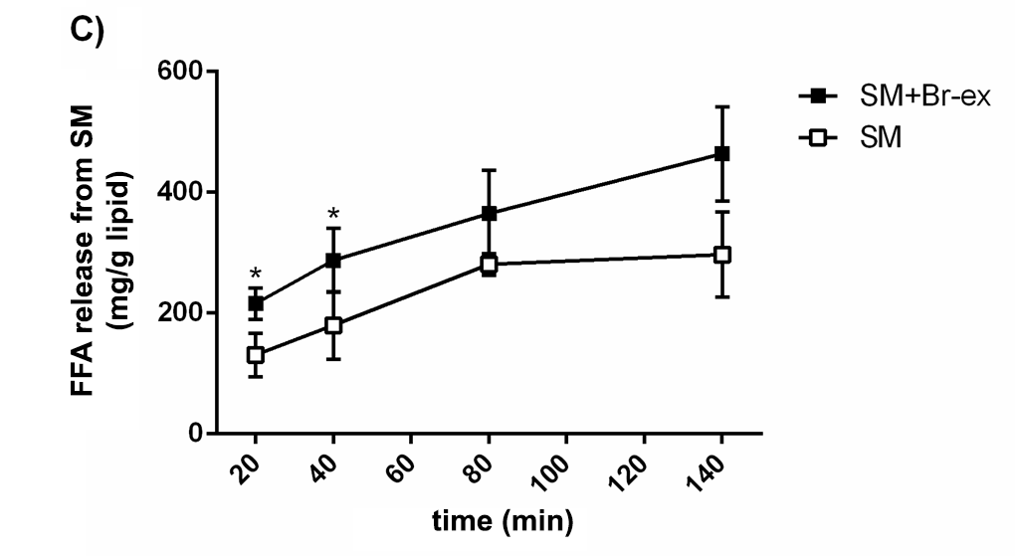
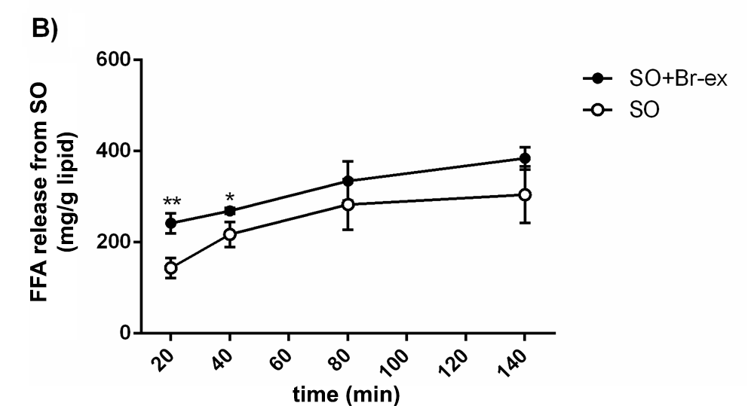
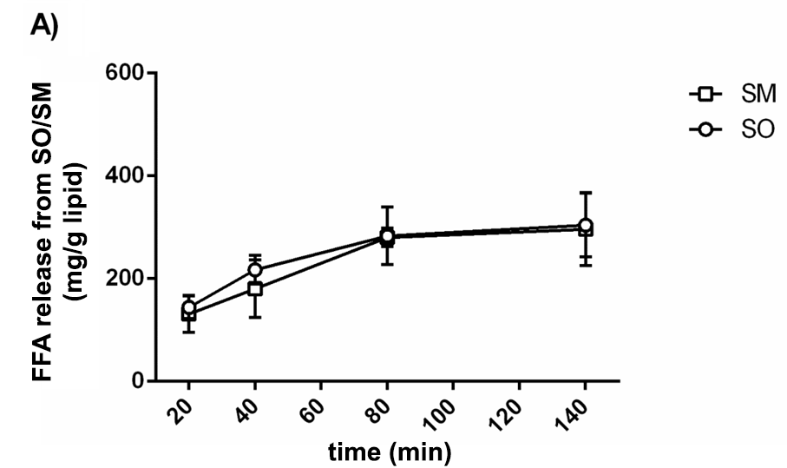

Figure 1 Release of FA from salmon oil (SO) and salmon muscle (SM) during in vitro duodenal digestion (37 °C for 140 min) (A), with and without addition of Br-extract (B and C), measured as mg FFA per g lipid in SO or SM. The results are given as mean ± SD (n=3). Significant differences are given as */** (P<0.05/ P<0.01).

Figure 2
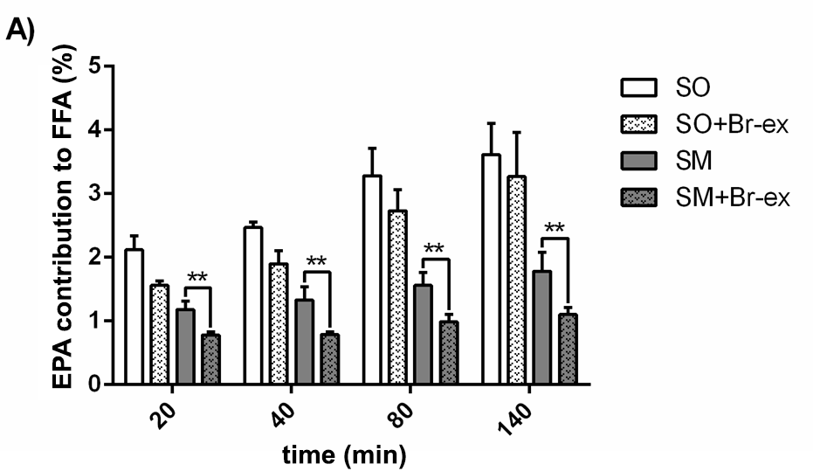
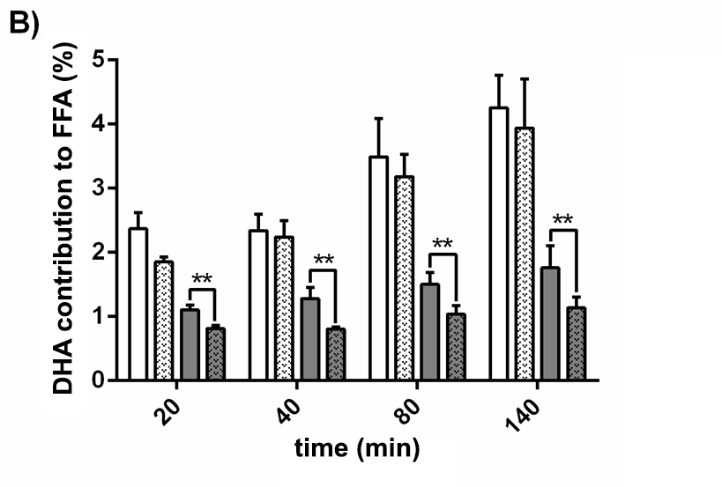

Figure 2 Percent EPA (A) and DHA (B) in the FFA fraction. Values are given as mean ± SD (n=3). Significant differences between SO and SO+Br-ex, and SM and SM+Br-ex, are given as */** (P<0.05/<0.01)

