Molecular diversity of the equine caecal microbiota and its correlation to postprandial fermentation metabolites: a preliminary approach
Running Title: Short-term dynamics in equine caecal microbiota

Hansen, N.C.K.¹, Mydland, L.T.¹, Næsset, J.A.¹, Austbø, D.¹, Måge, I.³ and Rudi, K.²

¹ Department of Animal and Aquacultural Sciences, Norwegian University of Life Sciences, Norway; ² Department of Chemistry, Biotechnology and Food, Norwegian University of Life Sciences, Norway; ^{3,} Nofima, The Norwegian Institute of Food, Fisheries and Aquaculture Research, Norway

*Corresponding author. E-mail: Knut.rudi@umb.no

Key words: 16S rDNA, caecal postprandial dynamics, microbiota, volatile fatty acids (VFA), equine
Abstract
Aim: In this work we address the short-term postprandial dynamic changes in the equine caecal microbial composition and the microbial fermentation metabolites in the caecum.
Methods and Results: Samples were collected every half hour for 8.5 hours post feeding from two horses at 2 consecutive days. The caecal content of volatile fatty acids (VFAs), lactate and ammonia (NH₃N), as well as microbiota composition and pH were analyzed. Mixed Sangers sequences generated from universal PCR-amplified 16S rRNA gene were used to analyze the microbiota composition. Three main phylogroups were identified and classified as Clostridium cluster XIVa, Clostridium cluster III and lactic acid bacteria (LAB). Furthermore, we found that the composition of the caecal microbiota was closely associated with the VFA profile.
Conclusion: Our main findings were that short-term microbial fluctuations occur in healthy hindgut fermenting horses as a response to feed intake.

Introduction
To be able to utilize a wide variety of diets, mammals have developed different strategies involving physical adjustments and development of a mutualistic relationship with their gastrointestinal (GI) microbiota (Ley et al. 2008, Mackie 2002). While ruminants have developed an enlarged foregut for fermentation, equines rely on hindgut fermentation. Generally, gastrointestinal fermentation is of high importance for equine digestion and health, yet excessive hindgut fermentation may lead to an adverse acidotic state ((de Fombelle et al. 2001, Jeejeebhoy 2002)).
Our knowledge about the normal short-term fluctuations in the equine gut microbiota as a response to feeding is currently superficial. This is mainly due to the complexity of the GI microbiota and technical obstacles in measuring and evaluating bacterial activity (Petrosino et al. 2009, Singh et al. 2009). Bacterial diversity of microbiota from faecal samples (Costa et al. 2012, Daly et al. 2001, Shepherd et al. 2012), from caecal and colonic samples from slaughtered horses (Daly et al. 2001) and caecal samples from caecally cannulated horses (Milinovich et al. 2008) has been characterized. However, short term meal induced changes in the caecal microbiota has not been investigated in vivo, nor been related to the production of VFAs.
The aim of this study was therefore to evaluate if there is a link between short-term postprandial dynamics in the equine caecal microbiota and metabolites.
The methods used were a mixed 16S rRNA gene sequencing approach (Zimonja et al. 2008), in combination with measurements of caecal volatile fatty acids (VFAs), ammonia (NH₃N) and pH. Multivariate statistical analyses were used to describe the relationship between the caecal microbiota and the caecal microbial metabolites.

Materials and methods
Animals, management, experimental feeds and diets
The horses were cared for according to the laws and regulations controlling experiments using live animals in Norway (i.e., the Animal Protection Act of December 20, 1974, and the Animal Protection Ordinance concerning Experiments on Animals of January 15, 1996) and remained healthy during the entire experimental period. Two Norwegian coldblooded trotter geldings (age 11 and 14, bodyweight 550 and 560 kg) were used in the study. The horses were each fitted with a permanent caecal cannula. The surgical procedure of cannulation was completed more than a year before this experiment using a technique with Domosedan (ATCvet-nr.QN05 M90) sedation and local anesthesia at the area of insertion.
The ration consisted of barley pellets (52.8 g kg DM⁻¹ starch) and late cut timothy hay (677 g NDF, 94 g CP, 7.3 MJ ME kg DM⁻¹). The daily diet was offered in three meals: at 08:00, 16:00 and 22:00 h. The daily ratio of barley (2 g starch kg BW⁻¹) was offered in the morning meal, mixed with 2 kg late cut timothy hay. The last two meals each consisted of 2.5 kg late cut timothy hay.
The horses were adapted to the forage for 9 months and the concentrate for 7 days. The horses were housed in individual boxes of 9 square meters bedded with sawdust during the sampling days. They had ad libitum access to water from automatic bowls. Before the trial the horses were turned out daily in a paddock for 6-7 hours. In addition, the horses were exercised daily for 1 hour in an automatic rotary exerciser with variable speed between 1.1-4.75 m s⁻¹.

Caecal sampling
A representative sample of the caecal chyme was manually evacuated through the caecal cannula before the morning meal and thereafter every half hour until the next feeding. The total daily sample number for each horse was 17. Five ml of each sample was conserved in tubes containing 5 ml of 99% ethanol and stored at -20°C until DNA extraction (Caldwell and Lattemann 2004, Paithankar and Prasad 1991, Vlckova et al. 2012, Yoshikawa et al. 2012). Ten ml was saved in tubes containing 1 ml of formic acid and stored at 4°C until analysis of VFA, ammonium-N and L- and D-lactate.
On the sampling days, pH was measured every 5 minutes for 8.5 hours post-feeding using a pH electrode (Polyplast DIN 60, Hamilton Bonaduz AG, Bonaduz, Switzerland) placed directly into the caecum through the cannula, and a pH meter (WTW, pH 340i, Ehlert & Partner, Munich, Germany) attached to the horse. The cannula was sealed by a silicone rubber plug to avoid oxygen exposure.
Chemical analysis
All caecal samples were analyzed for VFA by gas chromatography using the PerkinElmer Autosystem (PerkinElmer Inc., Norwalk, CT, USA) with a Restek Stabilwax® column (Restek, Bellefonte, PA, USA). Caecal samples for L-and D-lactate measurements were adjusted to pH 8-10 prior to analysis using commercial kits (D-lactic acid/ L-lactic acid, Boehringer Mannheim, IN, USA). Ammonium was analyzed by flow-injection-analysis (J. Ruzicka and E.H. Hansen 1981) based on Tecator application no. ASTN 22/89 (Foss Tecator AB, Höganas, Sweeden).

Bacterial DNA analysis
Bacteria and partly digested feed particles in the ceacal samples were harvested by centrifugation at 4600 rpm (Multifuge 3 SR Plus Centrifuge, DJB Labcare Ltd, Newport Pagnell, Buckinghamshire, England) for 10 min, the supernatant was removed and the pellet was resuspended in 10 ml of solution 1 (50 mM glucose, 25 mM Tris-HCL pH 8.0, 10 mM EDTA pH 8.0) and then diluted 1:2. Next, 200 µl of the caecal bacteria-suspension was diluted 1:4 in 4M guanidinium thiocyanate (GTC) and 500 µl were transferred to a FastPrep® tube (Qbiogene Inc., Carlsbad, CA, USA) containing 250 mg glass beads (>106 microns, Sigma-Aldrich, Steinheim, Germany). The samples were homogenized for 40 seconds in the FastPrep® instrument (Qbiogene Inc., Carlsbad, CA) before automatic DNA extraction. DNA isolation and purification were performed using an automated procedure with silica particles (Bioclone Inc., San Diego, CA) (Skanseng et al. 2006) .
After DNA extraction, universal 16S RNA-targeted primers were used for PCR amplification (Nadkarni et al. 2002). Primers used in the amplification reactions where forward primer 5`-TCCTACGGGAGGCAGCAGT-3` (Tm, 59.4°C) and reverse primer 5`-GGACTACCAGGGTATCTAATCCTGTT-3` (Tm, 58.1°C). The PCR mixture contained 0.2 µM of each primer, 1 U DyNAzymeTM II Hot Start DNA polymerase, 1x Hot Start Buffer, 200 µM dNTP mix, and 5.0 µl DNA in a 25 µl PCR reaction. The amplification profile consisted of an initial step of 94°C for 10 minutes, followed by 30 cycles of 94°C for 30 seconds, 60°C for 30 seconds and 72°C for 30 seconds, and a final extension at 72°C for 7 minutes. A universally conserved primer 5`-GTGCCAGCMGCCGCGGTA-3` (Baker et al. 2003) with C-tail extension (U515Fc30) consisting of 30 bases on the 5`-end was used for sequencing of mixed PCR products. In addition to direct sequencing of mixed PCR products, sequence cloning was performed. Mixed PCR products were cloned using a TOPO TA Cloning® Kit (Invitrogen, Carlsbad, CA, USA) according to instructions supplied by the manufacturer. The sequencing of the mixed and cloned PCR products were done using the same protocol following the recommendations by the manufacturer (Applied Biosystems, Foster City, CA, USA).
Preprocessing and resolving of mixed 16S rRNA gene sequences
Mixed DNA spectra were filtered, aligned and trimmed according to a procedure implemented in MATLAB® R2010b (MathWorks 2010b, Zimonja, Rudi, Trosvik and Naes 2008). Signature sequences were identified and the concentration profiles of these sequences were resolved by multivariate curve resolution (MCR) on the spectral data using a constrained alternating least squares (ALS) algorithm with non-negativity and closure as constraints (Unscrambler® software v9.6, CAMO Software Inc., Woodbridge Township, NJ, USA). The algorithm firstly identifies rank, or dimensionality of the data. In the next step the pure spectra and concentrations of these are identified, assuming closure of the data (Zimonja, Rudi, Trosvik and Naes 2008). The final number of components selected was determined by the shape of the explained variance curve. When additional components did not increase the explained variance no further components were added.
Classification of pure sequences and resolved signature sequences
Sequences were taxonomically assigned using the Ribosomal Database project (RDP) Classifier (Cole et al. 2006, Wang et al. 2007) (http://rdp.cme.msu.edu/classifier/classifier.jsp).
The cloned 16S rRNA gene sequences were used for taxonomic assignment of the resolved mixed sequences. The selection of the best matching DNA sequences was performed by a simple selection algorithm implemented in MATLAB® R2010b. First, the similarity score values were calculated between the signature sequence and pure DNA sequences within a clone library, according to the Smith-Waterman algorithm (swalign in MATLAB®). Second, the DNA sequences from one clone library were ranked according to their similarity score values. Third, a certain number of the highest ranked sequences were selected according to Eq. 1.
(Eq. 1)
The symbol Ф(i) defines the number of selected clones from one clone library, i, when the bacterial DNA sequences were aligned against one of the signature sequences, n. The ψ(i) symbol represents the estimated concentration calculated by MCR-ALS, and the ς symbol, represents the total number of clones in the clone library in question. A cutoff value of 25% present was chosen to limit the number identities in the phylogenetic tree.
Sequence alignment was performed using the CLUSTAL W- alignment function in Bio-Edit. The neighbor joining tree was constructed with 100 bootstraps, choosing Kimura two-parameter as a substitution model, by an online program, BioNJ available at: www.phylogeny.fr (Dereeper et al. 2008) . Dendroscope (Huson et al. 2007) was used to draw phylogenetic trees.
Nucleotide sequence accession numbers.
The nucleotide sequences of 16S rDNA were deposited in the database of NCBI-GenBank® using the BankIt submission tool. Sequencing reads were deposited in the GenBank® Archive under accession no. BankIt1506890. The 861 partial 16S rDNA sequences from the clone libraries described above were deposited under accession number JQ398862-JQ399722.

Principal component and statistical analyses of time series
The data were collected in a matrix X, where each row represents a physical caecal sample (for a given horse, day and time) and each column represent a measured or derived quantity (pH, fatty acid, NH₃N, bacterial groups). A Principal Component Analysis (PCA) was performed to get an overview of the main variation patterns in the data. All variables were scaled to unit variance and centred before the analysis since PCA is sensitive to variable scaling.
Significance of differences in bacterial abundances was tested by a two tailed unpaired t-test.

Results
Identification and classification of the main caecal microbial groups
Four bacterial groups were resolved by MCR-ALS (Figure 1). A fifth component clearly reflected technical noise (strong intensity dropping), and was thus omitted in further analyses. Only three signature sequences were possible to read, while the fourth component was highly mixed and no signature sequence could be identified (Supplementary Figure S2-S4). The three signature sequences each consisted of 230 nucleotides.
To obtain pure bacterial identities, a set of samples were chosen for cloning and sequencing (marked 1-11 in Figure 1). The choice of 11 samples was based on MCR-ALS concentration profiles, spanning the largest differences in bacterial composition. Three sets of bacterial DNA sequences were collected, representing 169 bacterial identities with highest similarity toward the three resolved mixed signature sequences. Phylogenetic clustering revealed the first bacterial component to be related to lactic acid bacteria (LAB), the second bacterial component to be related to Clostridial cluster III and the third bacterial component to be related to Clostridial cluster XIVa (Figure 2, Supplementary Figure S5 and S6).
Differences in bacterial composition
The concentration values of the bacterial groups were relative values, thus they were unit less. The mean value of Clostrial cluster III was 0.30 for horse 1 and 0.07 for horse 2 (p<0.05, two tailed unpaired t-test), while the concentration values for Clostridial cluster XIVa were 0.39 for horse 1 and 0.58 for horse 2 (p<0.01, two tailed unpaired t-test). Despite individuality in the abundance of Clostridial cluster XIVa, this particular bacterial group was the most abundant in the first samples of each time series (mean values for horse 1 and 2 were 0.45 and 0.59 respectively). The mean abundance of LAB in horse 1 was 0.08 and 0.18 for horse 2, and there was an individual difference in the abundance of LAB as well (p<0.01, two tailed unpaired t-test). In addition, the abundance of LAB had the most prominent time-dependent development: The increase in LAB was most prominent in the caecum of horse 2, as the abundance of LAB changed from 0.17 to 0.68 (sample 7.5 and 8 hours post feeding) the first experimental day and then 0.12 to 0.5 (sample 6 and 6.5 hours post feeding) the second experimental day.
Postprandial caecal fermentation characteristics
The postprandial caecal fermentation parameters are summarized in Figure 4. The caecal NH₃N concentration increased the first 30 minutes after feeding, and then decreased very quickly and remained relatively low for most of the remaining period until next feeding (< 5 mg L⁻¹). The caecal VFA concentration increased the first 2-3 hours after feeding, and remained at a relatively high level throughout the sampling period. The caecal pH minimum was between 4 and 5 hours after feeding, however, the caecal pH did not go below 6 for any of the measurements.
Individuality in postprandial caecal fermentation parameters were tested by a two tailed unpaired t-test. The overall mean proportion of acetate in horse 2 was significantly higher than in horse 1 (69.59 and 68.55 mol%, respectively; p<0.05, two tailed unpaired t-test), whereas the overall mean proportion of propionate in horse 2 was significantly lower than in horse 1 (21.52 and 24.16 mol%, respectively; p<0.05, two tailed unpaired t-test). However the overall mean postprandial values of L-lactate (0.09 versus 0.10 g/L) and D-lactate (0.03 versus 0.04 g/L) did not differ significantly between the two horses (Figure 5). The minor caecal VFAs (butyrate, iso-butyrate, valerate, and iso-valerate) only showed minor postprandial changes (Supplementary Figure S1).

Correlations between caecal VFAs and bacterial phylogroups
PCA was used to explore the linear relationships between all the analyzed variables in the caecal samples. The loading plot illustrates how well the different variables are correlated with the first two principal components capturing 35% and 29% of the variance in the dataset (Figure 3). The abundance of LAB was correlated with the first principal component while abundance of Clostridia was correlated with the second principal component. In addition, the loading plot also revealed correlations between bacterial components and caecal parameters. LAB was correlated with D-lactate and L-lactate and negatively correlated with pH. Acetate was correlated with Clostridial cluster XIVa and propionate was correlated with Clostridial cluster III. There was an inverse relation been VFA versus pH and VFA versus NH₃N (Figure 4). The most prominent correlations between bacterial groups and caecal parameters seemed to be related to individual- and time-dependent separation (Figure 5).
Discussion
Our main findings were that there are short-term microbial fluctuations in the caecum of healthy horses as a response to a meal, and that correlations were found between bacterial groups and microbial metabolites. We also found repetitive individual patterns for the two horses investigated for the two consecutive morning meals.
The transit time of the ingesta from feeding to it reaches the caecum can be estimated from logging pH values directly in the caecum of caecally cannulated horses. After a morning meal (grass hay and barley) caecal pH declined markedly about 2 hours post feeding and reached its lowest values 5-6 hours post feeding (Brøkner et al. 2012). Sampling until 8 hours post feeding should according to this be sufficient to investigate the short time effects of a meal on the caecal microbiota.
The dominating presence of Clostridia cluster XIVa was in agreement with a previous study of the caecal microbiota of slaughtered horses (Daly, Stewart, Flint and Shirazi-Beechey 2001). In addition, we observed a high abundance of the bacterial phylum Firmicutes, which was in agreement with several recent studies of the equine faecal microbiota (Costa, Arroyo, Allen-Vercoe, Stampfli, Kim, Sturgeon and Weese 2012, Shepherd, Swecker, Jensen and Ponder 2012). However, since different experimental diets and feeding regimes have been used it is difficult to do comparisons. In addition, the origin (faeces, colon, caecum) of the collected samples and differences in the laboratory technical procedures used to characterize the microbiota may complicate comparisons between studies (de Fombelle et al. 2003, Zoetendal et al. 2004).
Postprandial fluctuations were observed in three main caecal bacterial groups, all representatives of the bacterial phylum Firmicutes. With respect to the function of Clostridial cluster XIVa and III in the GI tract, a strong correlation were found between Clostridial cluster XIVa and the caecal acetate concentration and between Clostridial cluster III and the caecal propionate concentration. In addition, a high correlation was observed between abundance of LAB and L and D- lactate in the caecum. It is known that members of these bacterial groups are naturally L- and D-lactate-producers in the equine caecum (Al Jassim and Andrews 2009). Similar observations have also been made by (Daly et al. 2012) for horses fed a concentrate diet. Interestingly, LAB are also correlated with the onset of laminitis (Milinovich et al. 2008, Rudi 2010, Steelman and Chowdhary 2012), which indicates that normal feeding regimes may lead to preclinical disease states.
In conclusion, our main findings were that short-term microbial fluctuations occur in healthy hindgut fermenting horses as a response to feed intake and correlations were found between bacterial groups of the caecal microbiota and microbial metabolites in the equine caecum. These correlations concern the abundance of the bacterial phylum Firmicutes belonging to the Clostridial Cluster XIVa, Clostridial Cluster III, and LAB and the microbial metabolites acetate, propionate and lactate in the equine caecum.
Only two horses were used in the present study as it was seen as a preliminary study as basis for further studies. The use of cannulated horses is strictly regulated and the lowest number of experimental animals should be used. However, we realize that this caused limitations for the data interpretation.
Acknowledgements
We would like to thank Monica Sekelja for valuable methodological discussions and Signe Drømtorp for instructions regarding the practical work in the laboratory. Nofima is thanked for their financial support. Naja C. K. Hansen was supported by a PhD grant from The Norwegian University of Life Sciences, Ås, Norway.
References
Baker GC, Smith JJ, Cowan DA. 2003. Review and re-analysis of domain-specific 16S primers. J Microbiol Methods. Dec;55:541-555.
Caldwell RB, Lattemann CT. 2004. Simple and reliable method to precipitate proteins from bacterial culture supernatant. Appl Environ Microb. Jan;70:610-612.
Cole JR, Chai B, Farris RJ, Wang Q, Kulam-Syed-Mohideen AS, McGarrell DM, Bandela AM, Cardenas E, Garrity GM, Tiedje JM. 2006. The ribosomal database project (RDP-II): introducing myRDP space and quality controlled public data. Nucleic Acids Research. November 7, 2006;35:D169-D172.
Costa MC, Arroyo LG, Allen-Vercoe E, Stampfli HR, Kim PT, Sturgeon A, Weese JS. 2012. Comparison of the Fecal Microbiota of Healthy Horses and Horses with Colitis by High Throughput Sequencing of the V3-V5 Region of the 16S rRNA Gene. Plos One.7:e41484. Epub 2012/08/04.
Daly K, Proudman CJ, Duncan SH, Flint HJ, Dyer J, Shirazi-Beechey SP. 2012. Alterations in microbiota and fermentation products in equine large intestine in response to dietary variation and intestinal disease. Brit J Nutr. Apr 14;107:989-995.
Daly K, Stewart CS, Flint HJ, Shirazi-Beechey SP. 2001. Bacterial diversity within the equine large intestine as revealed by molecular analysis of cloned 16S rRNA genes. Fems Microbiol Ecol. Dec 26;38:141-151.
de Fombelle A, Julliand V, Drogoul C, Jacotot E. 2001. Feeding and microbial disorders in horses: 1 - Effects of an abrupt incorporation of two levels of barley in a hay diet on microbial profile and activities. J Equine Vet Sci. Sep;21:439-445.
de Fombelle A, Varloud M, Goachet AG, Jacotot E, Philippeau C, Drogoul C, Julliand V. 2003. Characterization of the microbial and biochemical profile of the different segments of the digestive tract in horses given two distinct diets. Anim Sci. Oct;77:293-304.
Dereeper A, Guignon V, Blanc G, Audic S, Buffet S, Chevenet F, Dufayard JF, Guindon S, Lefort V, Lescot M, et al. 2008. Phylogeny.fr: robust phylogenetic analysis for the non-specialist. Nucleic Acids Res. Jul;36:W465-W469.
Huson D, Richter D, Rausch C, Dezulian T, Franz M, Rupp R. 2007. Dendroscope: An interactive viewer for large phylogenetic trees. BMC Bioinformatics.8:460.
J. Ruzicka and E.H. Hansen 1981. Flow Injection Analysis New York Wiley-Interscience.
Jeejeebhoy KN. 2002. Short bowel syndrome: a nutritional and medical approach. CMAJ. May 14, 2002;166:1297-1302.
Ley RE, Lozupone CA, Hamady M, Knight R, Gordon JI. 2008. Worlds within worlds: evolution of the vertebrate gut microbiota. Nat Rev Microbiol. Oct;6:776-788.
Mackie RI. 2002. Mutualistic fermentative digestion in the gastrointestinal tract: Diversity and evolution. Integr Comp Biol. Apr;42:319-326.
2010b. USA: Inc. Massachusetts.
Milinovich GJ, Burrell PC, Pollitt CC, Klieve AV, Blackall LL, Ouwerkerk D, Woodland E, Trott DJ. 2008. Microbial ecology of the equine hindgut during oligofructose-induced laminitis. Isme J. Nov;2:1089-1100.
Nadkarni MA, Martin FE, Jacques NA, Hunter N. 2002. Determination of bacterial load by real-time PCR using a broad-range (universal) probe and primers set. Microbiology. January 1, 2002;148:257-266.
Paithankar KR, Prasad KSN. 1991. Precipitation of DNA by Polyethylene-Glycol and Ethanol. Nucleic Acids Res. Mar 25;19:1346-1346.
Petrosino JF, Highlander S, Luna RA, Gibbs RA, Versalovic J. 2009. Metagenomic Pyrosequencing and Microbial Identification. Clin Chem. May;55:856-866.
Rudi K. 2010. Dynamic host–bacteria interactions during an acidotic state induction. Environmental Microbiology Reports.no-no.
Shepherd ML, Swecker WS, Jensen RV, Ponder MA. 2012. Characterization of the fecal bacteria communities of forage-fed horses by pyrosequencing of 16S rRNA V4 gene amplicons. Fems Microbiol Lett. Jan;326:62-68.
Singh J, Behal A, Singla N, Joshi A, Birbian N, Singh S, Bali V, Batra N. 2009. Metagenomics: Concept, methodology, ecological inference and recent advances. Biotechnol J. Apr;4:480-494. Epub 2009/03/17.
Skanseng B, Kaldhusdal M, Rudi K. 2006. Comparison of chicken gut colonisation by the pathogens Campylobacter jejuni and Clostridium perfringens by real-time quantitative PCR. Mol Cell Probe. Oct;20:269-279.
Steelman SM, Chowdhary BP. 2012. Plasma proteomics shows an elevation of the anti-inflammatory protein APOA-IV in chronic equine laminitis. Bmc Veterinary Research. Sep 27;8.
Vlckova K, Mrazek J, Kopecny J, Petrzelkova KJ. 2012. Evaluation of different storage methods to characterize the fecal bacterial communities of captive western lowland gorillas (Gorilla gorilla gorilla). J Microbiol Methods. Jul 22;91:45-51. Epub 2012/07/26.
Wang Q, Garrity GM, Tiedje JM, Cole JR. 2007. Naive Bayesian Classifier for Rapid Assignment of rRNA Sequences into the New Bacterial Taxonomy. Appl Environ Microbiol. August 15, 2007;73:5261-5267.
Yoshikawa H, Hirano A, Arakawa T, Shiraki K. 2012. Mechanistic insights into protein precipitation by alcohol. Int J Biol Macromol. Apr 1;50:865-871.
Zimonja M, Rudi K, Trosvik P, Naes T. 2008. Multivariate curve resolution of mixed bacterial DNA sequence spectra: identification and quantification of bacteria in undefined mixture samples. Journal of Chemometrics. May-Jun;22:309-322.
Zoetendal EG, Collier CT, Koike S, Mackie RI, Gaskins HR. 2004. Molecular ecological analysis of the gastrointestinal microbiota: A review. J Nutr. Feb;134:465-472.

Titles and legends to figures
Figure 1. Relative abundance of the resolved bacterial phylogroups. The numbered red dots represent the specific samples chosen for cloning in order to capture as much variability related to the estimated concentration profiles as possible.

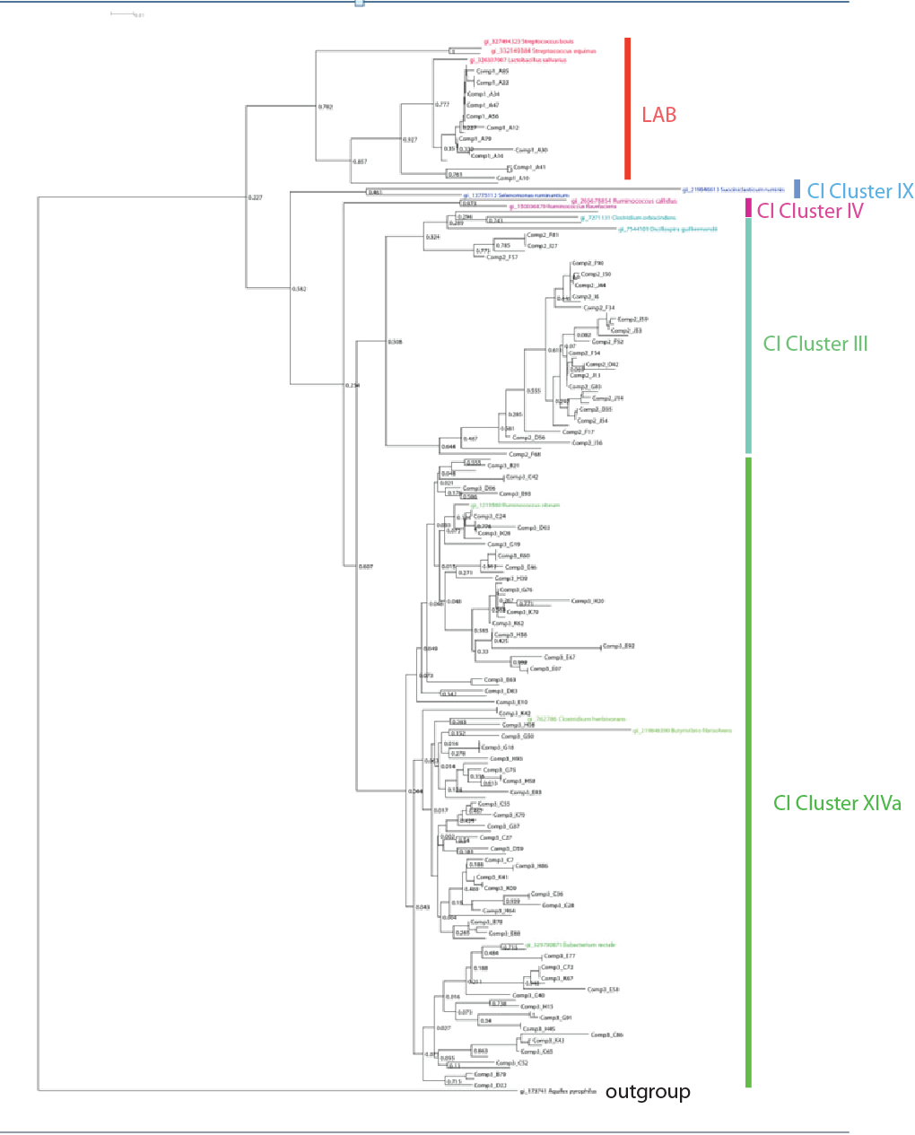
Figure 2. Phylogenetic tree representing the DNA sequences most similar to the resolved signature sequences. Reference bacterial strains representing five different bacterial cluster groups were colored red, blue, Turkish blue, purple and green representing members of respectively LAB, Clostridial Cluster IX, Clostridial Cluster III, Clostridial cluster IV and Clostridial cluster XIVa. Aquifex pyrophilus strain kol5a was used as an out-group bacterium.
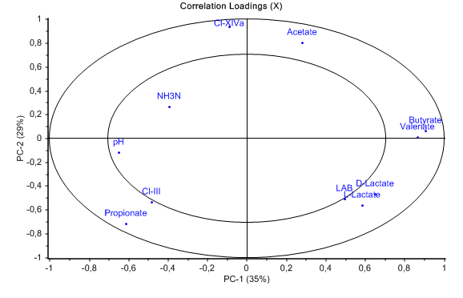
Figure 3. Correlation loading plot of parameters included in the PCA. The ellipses represent 50% and 100% explained variance (r²=0.5 and 1). The correlation loading plot reveals correlations between bacterial phylogroups and caecal parameters. Clostridial cluster XIVa is represented by Cl-XIVa, Clostridial cluster III is represented by Cl-III and Lactic acid bacteria is represented by LAB.

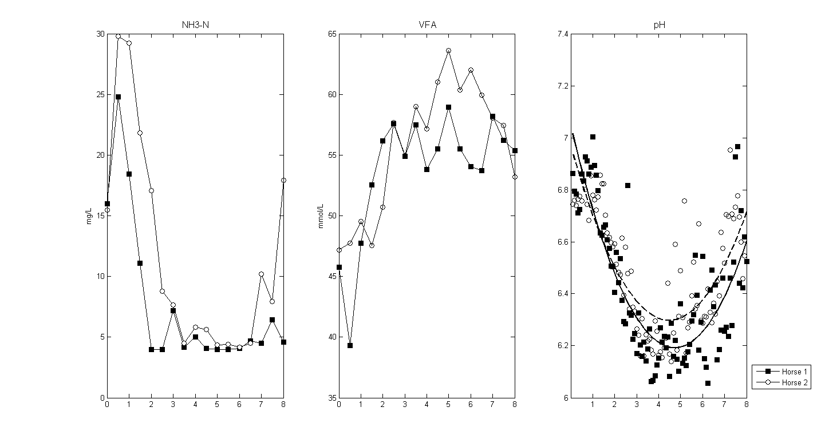

Figure 4. Caecal NH₃N, VFA and pH measurements. Mean values (two repetitions) from each horse are represented in the plot. Samples from horse 1 are marked by squares (■) and samples from horse 2 are marked by circles (○). A quadratic polynomial curve was fitted to the pH-measurements. The continued line (-) represents the polynomial model for horse 1, and the stippled line (---) represents the polynomic model for horse 2.

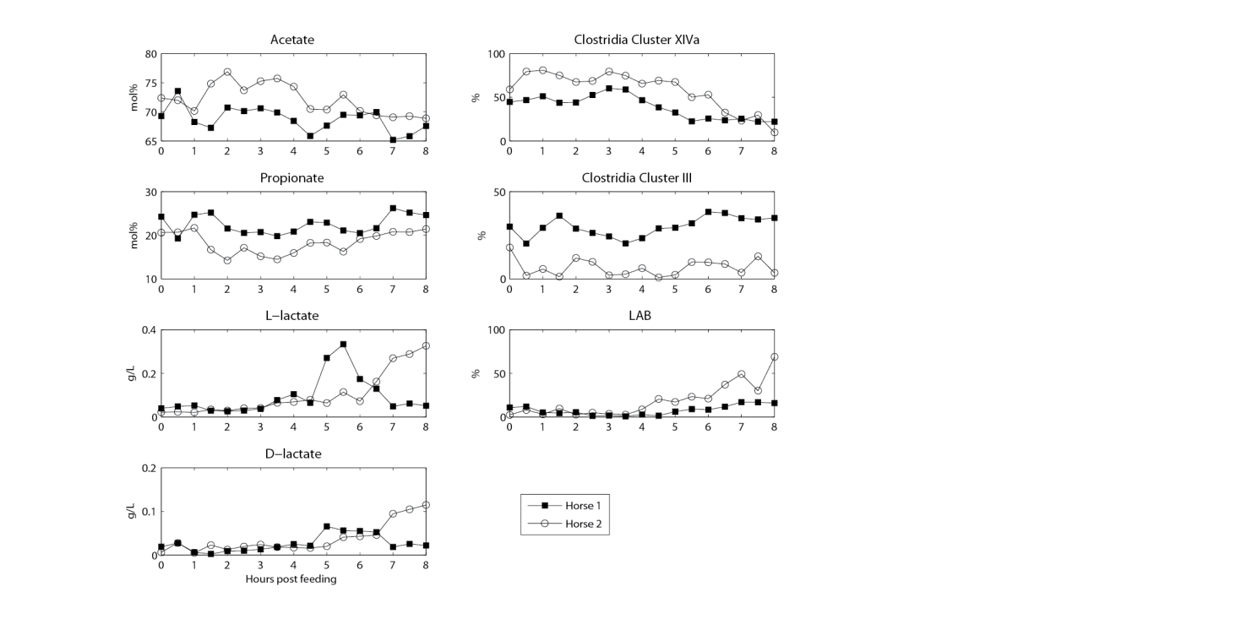
Figure 5. Postprandial VFA and bacterial concentration profiles. Mean values (2 repetitions) from each horse are represented in the plot. Samples from horse 1 are marked by squares (■) and samples from horse 2 are marked by circles (○).

